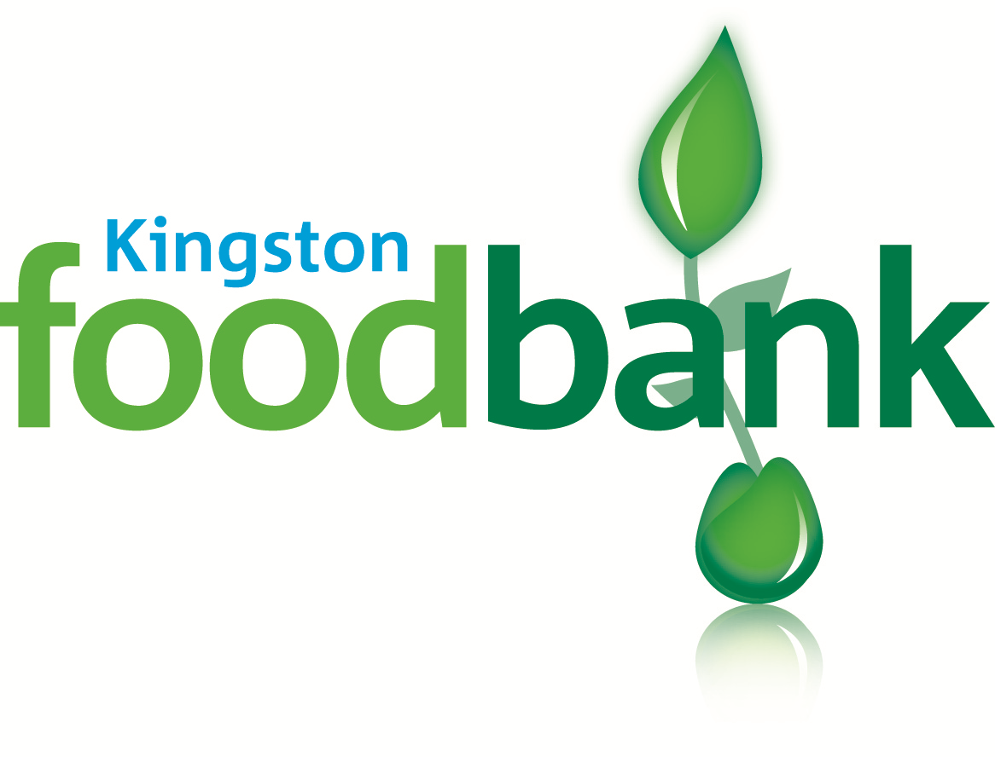

Gift Aid Declaration

for past, present & future donations

Please treat as Gift Aid donations all qualifying gifts of money made
today □ in the past 4 years □ in the future □
Please tick all boxes you wish to apply.

I confirm that I have paid or will pay an amount of Income Tax and/or Capital gains tax for each tax year (6 April to 5 April) that is at least equal to the amount of tax that all the charities or Community Amateur Sports Clubs (CASCs) that I donate to will reclaim on my gifts for that tax year. I understand that other taxes such as VAT and Council tax do not qualify. I understand the charity will reclaim 28p on every pound I gave up to 5 April 2008 and will reclaim 25p of tax on every £1 that I give on or after 6 April 2008.

Donor’s details

Title ....... First name or initial(s) ............................................................................

Surname .........................................................................................................................

Full home address............................................................................................................

.....................................................................................Postcode.....................................

Signature ..................................................... Date .....................................

Please complete the form and return to Kingston Foodbank, Unit 1b, Global House, Red Lion Business Park, Red Lion Road, Tolworth. KT6 7QD

Please notify the charity or CASC if you:
- want to cancel this declaration
- Change your name or home address
- No longer pay sufficient tax on your income and/or capital gains

If you pay Income Tax at the higher or additional rate and want to receive the additional tax relief due to you, you must include all your Gift Aid donations on your self Assessment tax return or ask HM Revenue and Customs to adjust your tax code.

